**Digital Business Management (DBM)**

**Overview of E-Commerce**

**Def:**

*E-Commerce or Electronic Commerce means buying and selling of goods, products, or services over the internet. E-commerce is also known as electronic commerce or internet commerce. These services provided online over the internet network. Transaction of money, funds, and data are also considered as E-commerce.*

*The standard definition of E-commerce is a commercial transaction which is happened over the internet. Online stores like Amazon, Flipkart, Shopify, Myntra, Ebay, Quikr, Olx are examples of E-commerce websites.*

**Advantages of E-Commerce:**

1. **Global Reach:** E-commerce provides the sellers with a global reach. They remove the barrier of place (geography). Now sellers and buyers can meet in the virtual world, without the hindrance of location.
2. **Lower the transaction cost**: Electronic commerce will substantially lower the transaction cost. It eliminates many fixed costs of maintaining brick and mortar shops. This allows the companies to enjoy a much higher margin of profit.
3. **Quick delivery of goods:** It provides quick delivery of goods with very little effort on part of the customer. Customer complaints are also addressed quickly. It also saves time, energy and effort for both the consumers and the company.
4. **Availability:** One other great advantage is the convenience it offers. A customer can shop 24×7. The website is functional at all times, it does not have working hours like a shop.
5. **Customer Service:** Electronic commerce also allows the customer and the business to be in touch directly, without any intermediaries. This allows for quick communication and transactions. It also gives a valuable personal touch.

**Disadvantages of E-Commerce:**

1. **Set-up cost:** The start-up costs of the e-commerce portal are very high. The setup of the hardware and the software, the training cost of employees, the constant maintenance and upkeep are all quite expensive.
2. **Risk:** Although it may seem like a sure thing, the e-commerce industry has a high risk of failure. Many companies riding the dot-com wave of the 2000s have failed miserably. The high risk of failure remains even today.
3. **Layout:** At times, e-commerce can feel impersonal. So, it lacks the warmth of an interpersonal relationship which is important for many brands and products. This lack of a personal touch can be a disadvantage for many types of services and products like interior designing or the jewelry business.
4. **Security:** Security is another area of concern. Only recently, we have witnessed many security breaches where the information of the customers was stolen. Credit card theft, identity theft etc. remain big concerns with the customers.

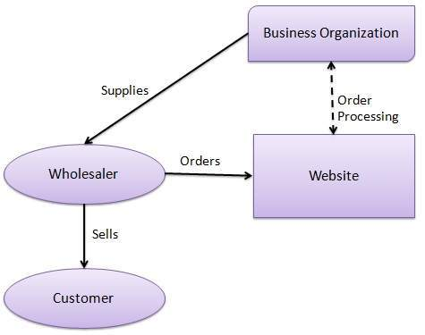**These business transactions can be done in four ways:**

1. **Business - to – Business (B2B):**

A website following the B2B business model sells its products to an intermediate buyer who then sells the product to the final customer. As an example, a wholesaler places an order from a company's website and after receiving the consignment, sells the end product to the final customer who comes to buy the product at one of its retail outlets.

1. 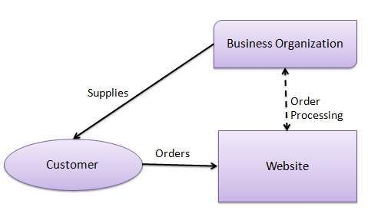**Business - to – Consumer (B2C):**

A website following the B2C business model sells its products directly to a customer. A customer can view the products shown on the website. The customer can choose a product and order the same. The website will then send a notification to the business organization via email and the organization will dispatch the product/goods to the customer.

1. 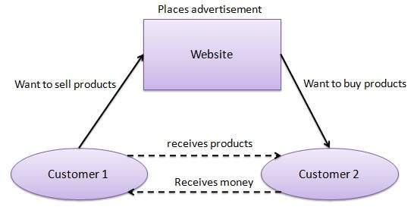**Consumer - to – Consumer (C2C):**

A website following the C2C business model helps consumers to sell their assets like residential property, cars, motorcycles, etc., or rent a room by publishing their information on the website. Website may or may not charge the consumer for its services. Another consumer may opt to buy the product of the first customer by viewing the post/advertisement on the website.

1. 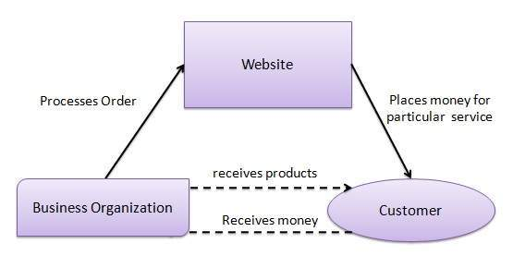**Consumer - to – Business (C2B):**

In this model, a consumer approaches a website showing multiple business organizations for a particular service. The consumer places an estimate of amount he/she wants to spend for a particular service. For example, the comparison of interest rates of personal loan/car loan provided by various banks via websites. A business organization who fulfills the consumer's requirement within the specified budget, approaches the customer and provides its services.

**B2B e-commerce:**

Business-to- Business E-commerce also known as Eb2b or just B2B. It refer to transaction b/w business conducted electronically over the Internet, Intranet, Extranet or private Network. Such transaction may take place b/w a business and its supply chain member. as well as b/w a business its customer and any other business In this a business refer to any organization private or public for profit or non profit.

B2B key business drives on the internet is to provide secure platform in private and public B2B E-marketplace the need of collaboration b/w supplier and buyers the ability to save money , reduce delay and improve collaboration and the emergence of effective for intra- and in inter organization integrati.

**The Basic Types Of B2B Transaction & Activities:**

The number of seller and buyers and the form of participation used in B2B determine the basic B2B transaction types.

* **Sell-Side:** one seller to many buyers.
* **Buy-Side:** One buyer to many seller.
* **Exchange:** many seller to many buyers.
* **Supply chain improvement & collaborative Commerce:** Activities other than buying or selling among business partner for example supply chain improvement, communicating, Collaborating and Sharing of Information for joint design planning and so on.

**The Basic Types Of B2B E-marketplace And Services:**

1. **One-To-Many & Many-To-One Private Emarketplace:** In One-To-Many and Many-To-Many market one company does either all of the selling or all of the Buying. Because EC is focused on a single company buying or selling need in these transaction this type of EC is referred to as CompanyCentric EC. Company-centric marketplace the individual sell-side or Buy-side company has complete control over who participates in the selling or buying transaction and the supporting information system. This type of transaction are essentially private
2. **Intermediaries:** One-To-Many or Many-To-One EC activities are conducted without the help of intermediaries however when it comes to auction, Aggregating buyers or complex transaction an intermediary frequently is used.
3. **Many-To-Many : Exchanges:** In Many-To-Many E-marketplace many buyers and many seller meets electronically for the purpose of trading with one another. There are different types of such E-marketplace which are also known as Exchange, trading communities. Exchange are usually owned and run by the third
4. **Supply Chain Activities & Collaborative Commerce:** B2B transaction are segments in the supply chain therefore B2B initiatives need to be examined in light of other supply chain activities such as manufacturing , procurement of raw materials and shipments and logistics. its usually involves communication and collaboration. Collaborative commerce is communication , design, planning and information sharing among business partners to qualify as collaborative commerce the activities that are shared must represent far more just financial transaction.

**E-Retailing:**

E-retailing essentially consists of the sale of goods and services. Sometimes we refer to this as the sale of tangible and intangible goods, We can divide tangible goods into two categories: physical goods and digital goods.

Examples of physical goods would be a book, a television set, a video recorder, a washing machine, etc.

Examples of digital goods are software and music, which may be downloaded from the internet.

The sale of intangible goods is sometimes called E-servicing.

Traditional retailing essentially involves selling to a final customer through a Physical outlet or through direct physical communication.

e.g., generalized stores (e.g. department store), specialized stores, franchise stores.

Thus, more recent forms of traditional retailing include - direct mailing, telemarketing, door-to-door sales and vending machines.

**Benefits:**

1. Convenience.

2. Better information.

3. Competitive pricing.

**Mobile commerce (M-Commerce):**

Mobile commerce, also known as m-commerce or mcommerce, is the use of wireless handheld devices like cellphones and tablets to conduct commercial transactions online, including the purchase and sale of products, online banking, and paying bills.

**Advantages of M-Commerce:**

1. Through M-commerce, the companies can be in regular touch with the users through the Push Notifications.
2. M-Commerce enables local business to grow by tracking the location of the potential customer and sharing the information on their mobile phones.
3. With the help of M-commerce, the users can pay their mobile bills, electricity bills, without standing in the long queues.
4. M-Commerce helps the marketer to have a wider reach of potential customers than he can have by visiting all personally.

**Disadvantages of M-Commerce:**

1. The Screen of mobile phones is generally small as compared to the computer screen and, therefore, the display of cellular gadgets may not influence the user to make the purchase.
2. Poor connectivity also hampers the M-commerce to flourish.
3. M-commerce, being the latest technology is struggling with its applications in terms of its graphics and the content that results in more reliance on the E-commerce applications.

The technology behind the M-commerce is WAP i.e. Wireless Application Protocol that enabled users to make use of the internet anytime and anywhere.

**E-Commerce Strategy:**

***Strategy:*** *A broad-based formula for how a business is going to compete, what its goals should be, and what plans and policies will be needed to carry out those goals.*

The formulation and execution of a vision of how a new or existing company intends to do business electronically. The Strategic Planning Process includes-

1. **Strategy initiation:** The initial phase of strategic planning in which the organization examines itself and its environment. Specific outcomes from the strategy initiation phase include:

* Company analysis: value proposition, the benefit that a company’s products or services provide to customers, the consumer need that is being fulfilled.
* Core competencies
* Forecasts
* Competitor (industry) analysis

1. **Strategy formulation:** The development of strategies to exploit opportunities and manage threats in the business environment in light of corporate strengths and weaknesses. Specific activities and outcomes from the strategy formulation phase include:

* Business opportunities
* Cost-benefit analysis
* Risk analysis, assessment and management
* Business plan

1. **Strategy implementation:** The development of detailed, short-term plans for carrying out the projects agreed on in strategy formulation. Specific activities and outcomes from strategy implementation phase include:

* Project planning
* Resource allocation
* Project management

1. **Strategy assessment:** The continuous evaluation of progress toward the organization’s strategic goals, resulting in corrective action and, if necessary, strategy reformulation.

**Affiliate Marketing:**

* In the simplest of terms, affiliate marketing is the process of paying a commission to customers whenever they bring in new customers to your business.
* It’s a win/win/win scenario: You earn a new customer, your referring customer (affiliate) gets paid, and your new customer gets introduced to your services.
* The affiliate marketing process involves the merchant – that’s you – and the affiliate.
* The affiliate, or publisher, is the company or individual that promotes your products and brand on their website.
* Your affiliate receives a commission when someone clicks through to your website and makes a purchase.
* Things To Consider When Developing Your Affiliate Program: Here are the top six things you need to know to start your own ecommerce affiliate program:

1. Do competitor research: Before you jump into the world of affiliates, analyze what your competitors are doing.
2. Know your affiliate program objectives
3. Have a defined commission strategy
4. Know your customer retention rate
5. Know customer lifetime value
6. Calculate your commission payouts